**Typos for correction on “A medium-sized, open-economy, fiscal DSGE model of South Africa”**

*Verified by Hylton*

* **The indexation is correct. However, for consistency with a later specification, it may be possible to adjust the AR(1) process notation.**

*Original paper:*

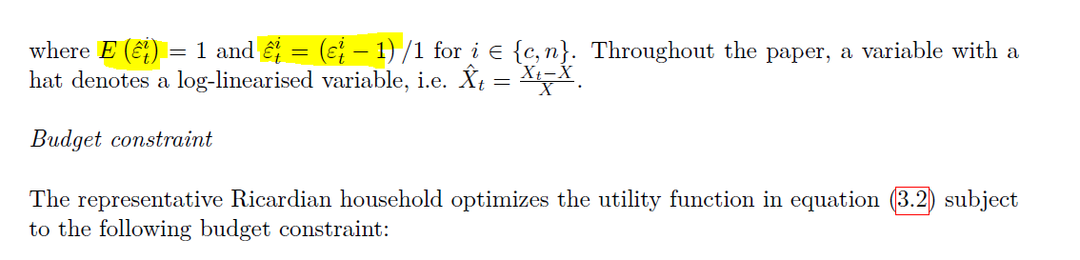

*Proposed notation:*

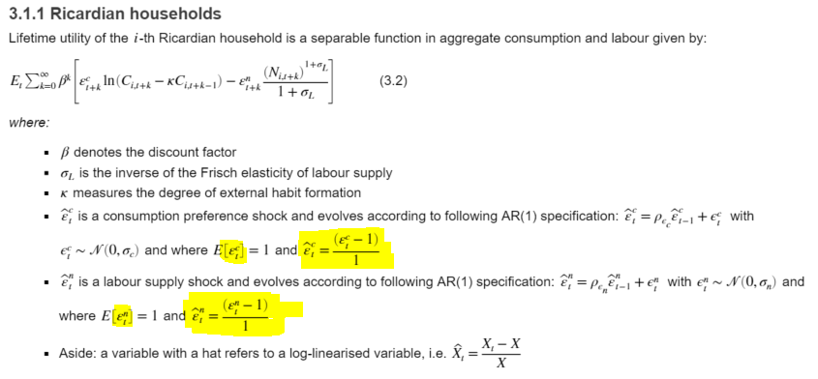

* **Missing subscript i**

*Original paper:*

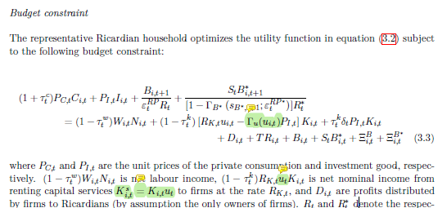

*Proposed notation:*



* **Add in lower case s.**

*Original paper:*

*Proposed notation:*

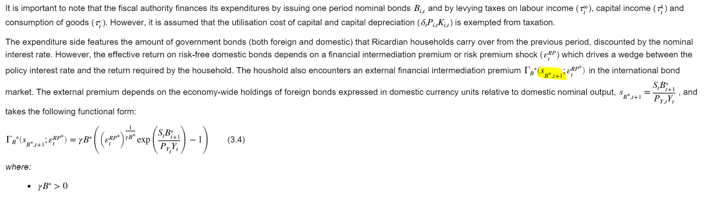

* **Adjust rho as follows.**

*Original paper:*

*Proposed notation:*

* **Investment adjust cost function (technical adjustment may be required as explained by Hylton)**

*Original paper:*

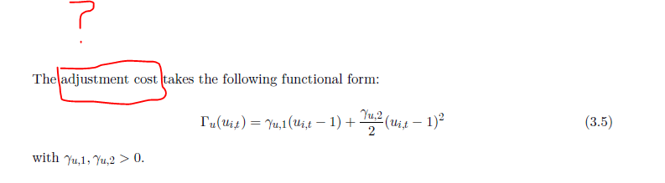

*Notes:*

* “The explicit functional form for capacity utilization is mysteriously missing in every paper going back to at least 2003… it is not a major issue though. One could “reverse engineer” it (it may look very similar to the investment adjustment cost… Harris explicit definition doesn’t work out exactly…” (Hylton on Slack)